# **COVID PATIENT TRACKER - SE Mini Project Report :**

Submitted in partial fulfillment of the requirements of the degree

**BACHELOR OF ENGINEERING** IN **COMPUTER ENGINEERING**

By

SAKSHI RANE D7B/55

SANJANA ASRANI D7B/01

DIVYANG PATEL D7B/49

DIMPLE MADHWANI D7B/36

**Mentor** : **Mrs**. **Yugchhaya Galphat**  
  


**Department of Computer Engineering**

**Vivekanand Education Society’s Institute of Technology**

**HAMC, Collector’s Colony, Chembur,**

**Mumbai-400074**

**University of Mumbai**

**(AY 2021-22)**

**CERTIFICATE**

This is to certify that the Mini Project entitled  **“  COVID PATIENT TRACKER   ”** is a bonafide work of **Sanjana Asrani (D7B/01), Dimple Madhwani (D7B/36), Divyang Patel (D7B/49) , Sakshi Rane (D7B/55)** submitted to the University of Mumbai in partial fulfillment of the requirement for the award of the degree of **“Bachelor of Engineering”** in **“Computer Engineering” .**

**(Prof. Yugchhaya Galphat)**

Supervisor

**(Prof. Dr.Nupur Giri ) (Prof. Dr.J.M.Nair )**

Head of Department Principal

**Mini Project Approval**

This Mini Project entitled “**COVID PATIENT TRACKER”** by **Sanjana Asrani(D7B/01), Dimple Madhwani (D7B/36), Divyang Patel (D7B/49),** **Sakshi Rane (D7B/55)** is approved for the degree of **Bachelor of Engineering** in **Computer Engineering.**

**Examiners**

**1…………………………………**

(Internal Examiner Name & Sign)

**2……………………………………**

(External Examiner name & Sign)

Date: 12/12/2021

Place: Mumbai

**Contents**

* **Abstract**
* **Acknowledgments**
* **List of Abbreviations**
* **List of Figures**
* **List of Tables**

**ABSTRACT**

The Covid-19 outbreak had taken over the world completely , exposing the vulnerability of public health systems in coping with infectious pandemic. This Project proposes work on Covid-19 *Data visualization* which helps people to defend against Covid-19 spread.Hence, A website that can read the data and visualize it efficiently such that it is readable even by common people would be of great help. Our website gathers all the information at one place and presents in an organized manner . State-wise and Country-wise Covid data , including recovered , deaths , cases have been graphed. Including , a Survey form (self-diagnosis questionnaire) , with User Authentication : signup and login , forum for user interaction and some more functionalities for admin like searching , pagination and CRUD operations .

**ACKNOWLEDGEMENT**

We are thankful for our Project Mentor **Yugchhaya Galphat** ma’am , who guided us and helped us throughout the project and SE Project Coordinator **Mrs. Vidya Zope** for giving us a chance to do this project . This project would not have been possible without their kind support.

**List of Abbreviations**

1. WHO - World Health Organisation
2. COVID – Coronavirus Disease
3. CPT – Covid Patient Tracker

**List of Figures**

1. 1)Flowcharts showing Website-flow (fig A , fig. B and fig. C ).
2. Conceptual Diagram.

**List of Tables**

* Literature survey table

***Organisation of the Report***

1. **Introduction** 
   1. Introduction
   2. Motivation
   3. Problem Statement & Objectives

1. **Literature Survey**
2. Survey and Limitation of Existing system or research gap
3. Mini Project Contribution

1. **Proposed System**
2. Introduction
3. Architecture/ Framework
4. Algorithm and Process Design
5. Details of Hardware & Software
6. Experiment and Results.
7. Conclusion and Future work**.**
8. **References**
9. **INTRODUCTION**

**1.1. Introduction to our project**

The Corona-virus pandemic has taken the world by storm with its rapid growth and spread.

Thus to analyze what has been its impact so far and analyze the situation of COVID 19 across various regions, visualize them using charts and tables, and showcase the number of confirmed cases,we have built a simple user friendly website .

Hence with a few safety measures, and updates , you can take care of yourself and your loved ones from getting adversely affected in the hour of crisis.

**1.2. Motivation**

COVID-19 Pandemic was an outburst that shook the world with its increasing number of patients day by day. Thousands of lakhs of cases were being discovered everyday , so maintaining an offline record of all the affected is neither feasible nor easy. Hence , we have created this website to provide accurate COVID information to our users taking the seriousness of the current situation and the learning opportunity as our motivation .

**1.3 Problem Statement & Objectives**

* Analyzing the present situation in India.
* Visualizing the data using graphs.
* Perform a self diagnosis based on the questionnaire in the survey form.
* To provide data and news updates about the current situation, thereby helping in analyzation of the extent of COVID-19.

1. **Literature survey**

**2.1. Survey and Limitation of Existing system**

|  |  |  |  |  |
| --- | --- | --- | --- | --- |
| Sr  No. | Paper | Authors | Year | Summary |
| 1. | Tracking and Mining the COVID-19 Research Literature. | Alan.L.Portal, Yi Zhang, Ying Huang, Mengjia Wu | 2020 | This paper has shown the importance of information that can help in improving reponse time and plan in advance to help reduce risk. |
| 2. | CoronaTracker:World wide COVID 19 Outbreak Data Analysis and Prediction | Hafez Nazric, Guanhua Lee, Cheng Liang Tanf, Mohammad Khursani Bin Mohd Shaibg | 2020 | Provides latest and reliable news development, as well as statistics and analysis on COVID-19. |
| 3. | COVID 19 Tracker Web System literature paper | Anubhav Soni, Navdeep Singh and Madhav Kumar | 2021 | The easy to use GUI clubbed with the interactive maps and graphs will help to provide the information that users need in order to stay updated with the COVID-19 situation. |
| 4. | COVID-19 Mobile Apps: A Systematic Review of the Literature | Haridimos Kondylakis, Dimitrios G Katehakis, Dimitrios Tzovaras. | 2020 | Detect and track the contagious person and also keep the patient's data record for analysis and decision making using edge computing. |
| 5. | Data Visualization for the Understanding of COVID-19 | João L. D. Comba, Universidade Federal do Rio Grande do Sul | 2020 | Visualization techniques have been front-and-center in the efforts to communicate the science around COVID-19. It helps to understand different aspects of the  pandemic. |
| 6. | A review of modern technologies for tackling COVID-19 pandemic | A. Kumar, P. K. Gupta and A. Srivastava. | 2020 | A brief review is done on the information by assessing various modern technologies for tackling COVID-19 pandemic. |
| 7. | Detection and Tracking Contagion using IoT-Edge Technologies: Confronting COVID-19 Pandemic. | M. U. Ashraf, A. Hannan, S. M. Cheema, Z. Ali and A. Alofi. | 2020 | proposed a smart edge surveillance system that is effective in remote monitoring, advance warning and detection of a person's fever, heart beat rate, cardiac conditions and some of the radiological features to detect the infected (suspicious) person using wearable smart gadgets. |
| 8. | Tracking COVID-19 by Tracking  Infectious Trajectories. | BADREDDINE BENREGUIA , HAMOUMA MOUMEN , AND MOHAMMED AMINE MERZOUG. | 2020 | propose an IoT investigation system that was specifically designed to spot both undocumented patients and infectious places and it also allows determining all persons who had close contact with infected or suspected patients. |

**2.2. Limitation of the Existing System and Research Gap**

* The user might be able to insert SQL injection, also known as SQLI, a common attack vector that uses malicious SQL code for backend database manipulation to access information that was not intended to be displayed.
* Complicated website designs make it difficult for user to easily navigate throught the webpages.

**2.3. Mini Project Contribution**

* User Authentication
* Responsive and Dynamic Website.
* User can perform self-diagnosis with the help of questionnaire(survey form).
* User interaction page (forum) .
* Visual Representation for effective comparison (covid data graphs).
* News updates about the situation (covid variants information).

1. **Proposed System**

**3.1. Introduction :**

Data is procured from authenticated sources like WHO, Indian Journal of Medical Research . It is visualized into different graphs of death rates, COVID cases, recovered cases across various countries in world and various states in India. It has authentication process for users , hence making it a secure website. The working of our proposed system is explained in the flowcharts given.

**3.2. Architecture/ Framework**

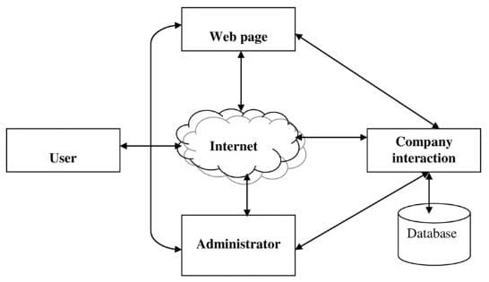

Fig A) Database flow

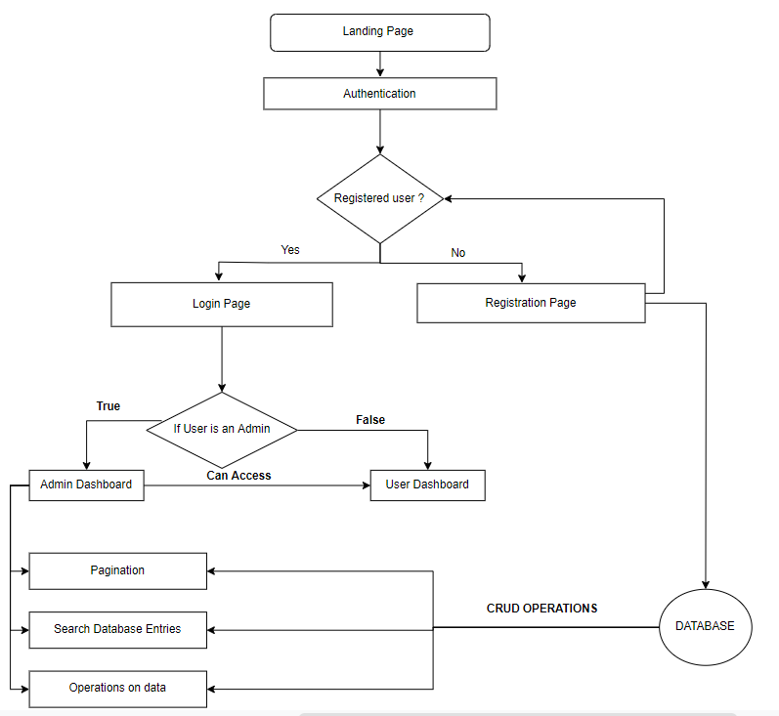

Fig B) Showing Flow of the website

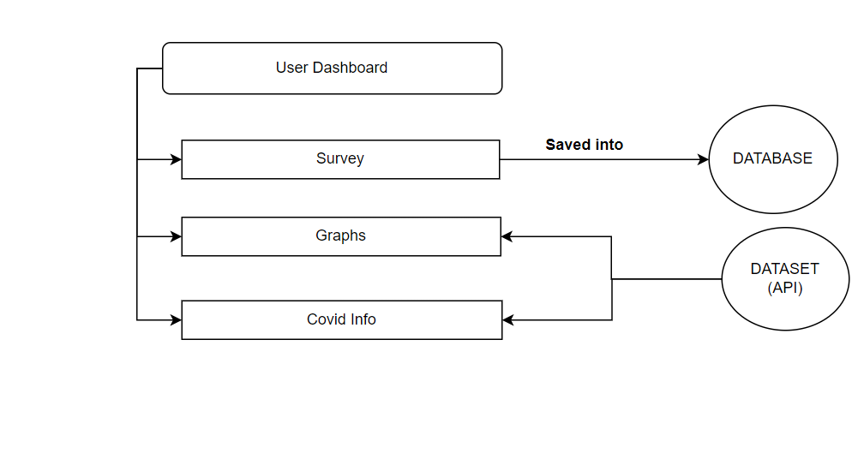

Fig C) Showing working of the user page

**3.3. Algorithm and Process Design**

*FRONTEND*

* HTML : Used for making the basic page layout.
* CSS , BOOTSTRAP : Used for styling the page.
* JS : For Logic part based on elements of html body.

*BACKEND*

* PHP & MYSQL : Used for database connectivity.

**Summarizing the work :**

* Database connectivity :

Creating several databases to store user inputs and respective information like responses of survey form , forum’s comments and threads , all existing users , etc.

* Web Development:

Developing web pages and then integrating into a website consisting of visualization model displaying facts and figures on current COVID cases.

* User Authentication :

Having a validated signup and login page for users to access all the functionalities of the website.

* Graph Plotting :

Extracting authenticated datasets from data sources like wikipedia ,WHO and kaggle to plot covid statistical data graphs using chart.js .

* User Interaction (Forum) :

Developing a page using mainly php where the users can come and talk , maybe about the website , perhaps want to share their covid experience or maybe give feedback .

**3.4. Details of Hardware & Software**

|  |  |
| --- | --- |
| **HARDWARE** | **SOFTWARE** |
| Processor: Intel i3 or AMD  equivalent. | HTML, CSS, BOOTSTRAP |
| Disk space: 4GB | PHP |
| RAM: 8GB | MYSQL( Xampp server) |
| GPU: Nvidia GPU | JAVASCRIPT |

**3.5. Experiment and Result (Snapshots)**

Landing Home page :

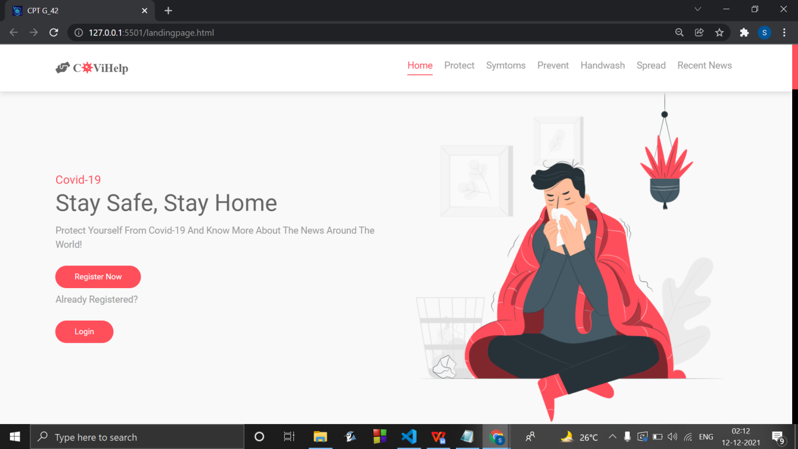

Section symptoms

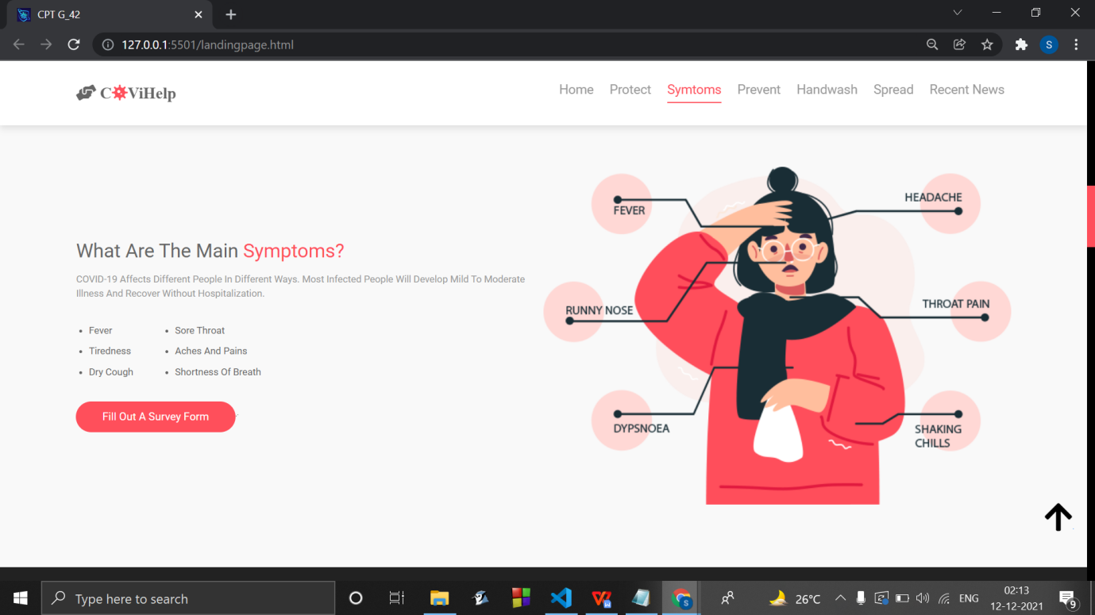

Prevent section

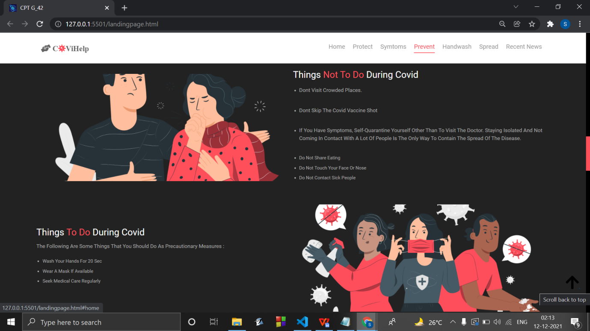

Footer showing summary of all functionalities implemented

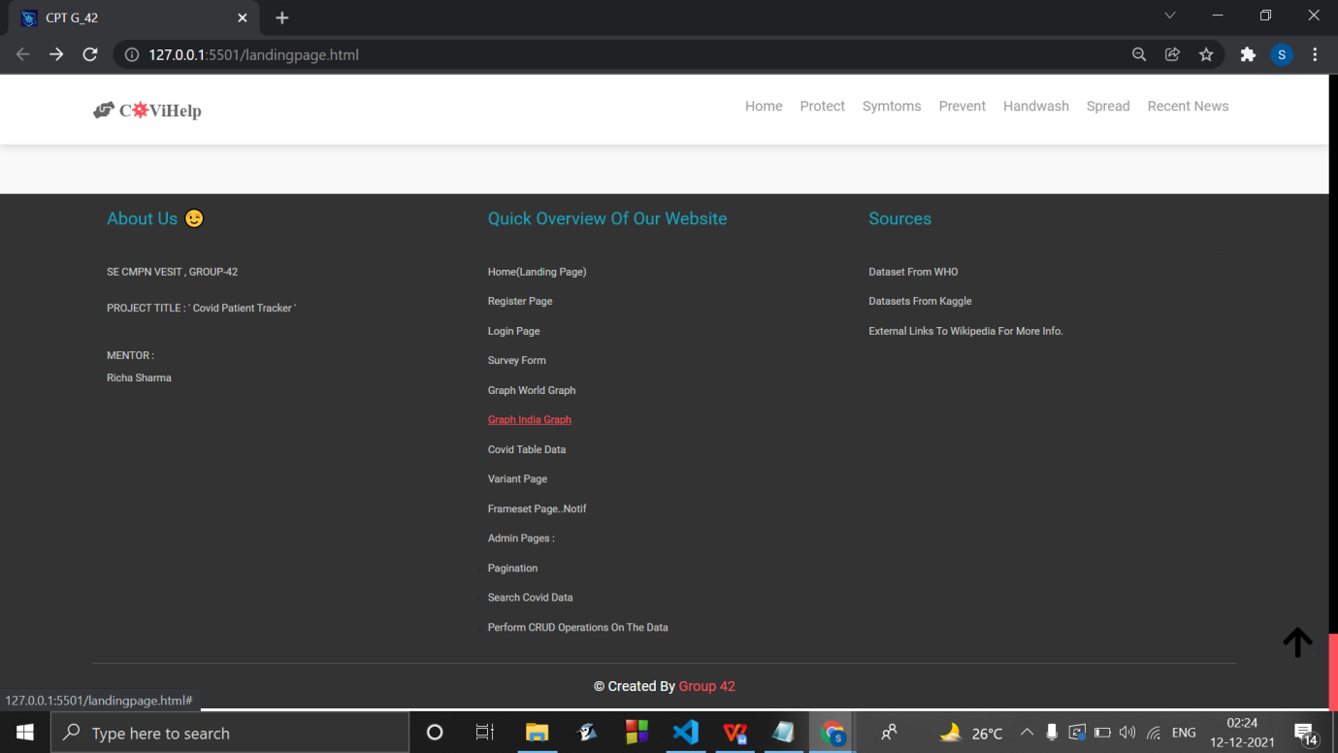

User authentication

Signup :

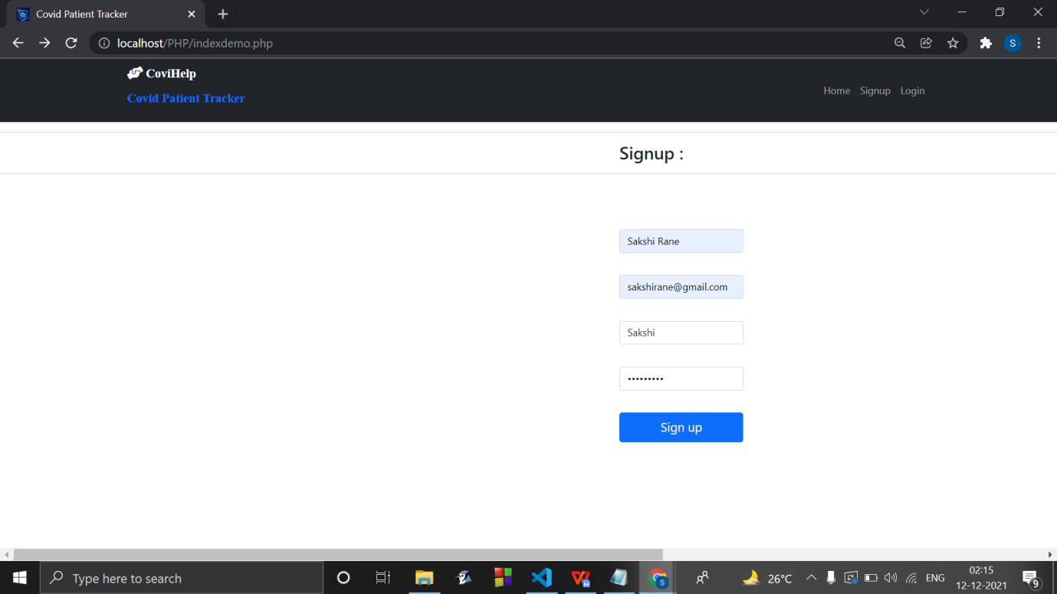

Email verification :

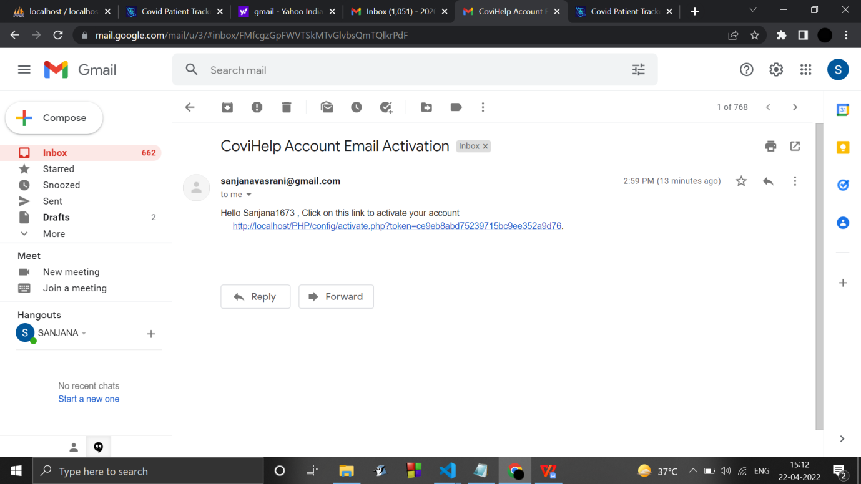

Login :

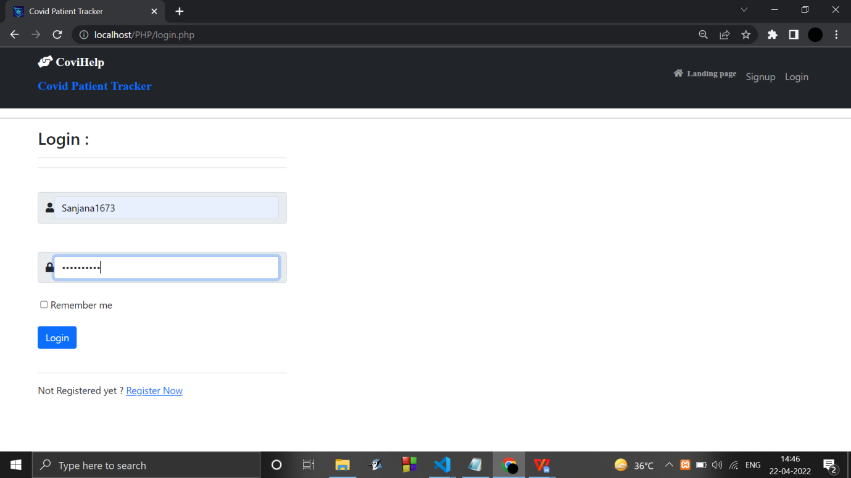

User Dashboard :

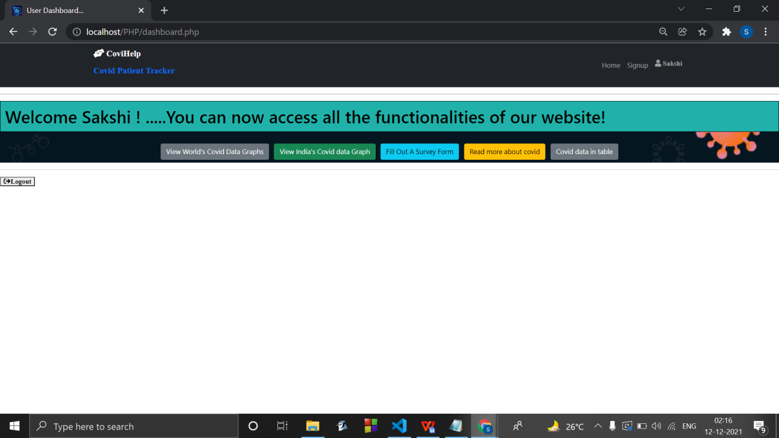

Covid World Data Graphs :

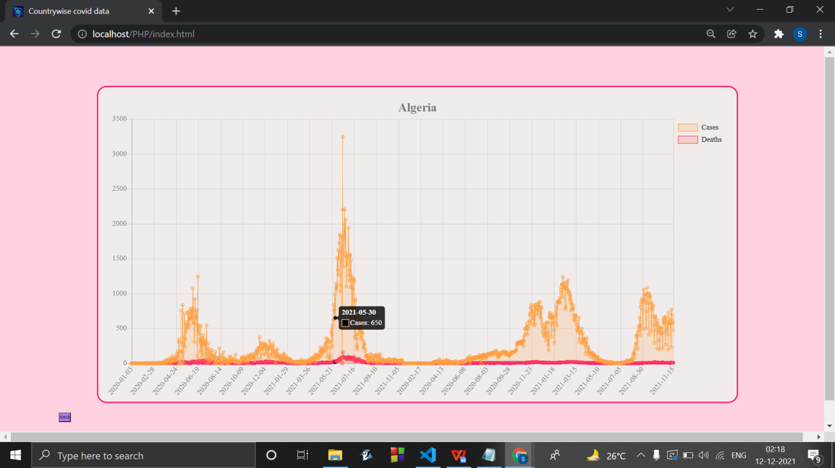

Covid India’s data graph :

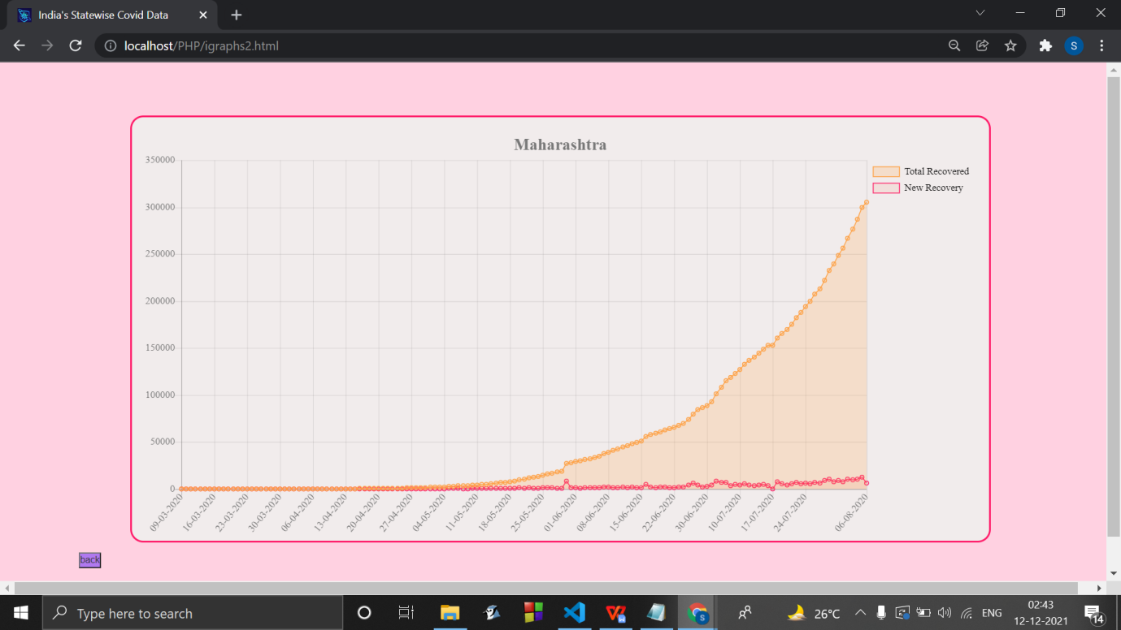

Survey Form :

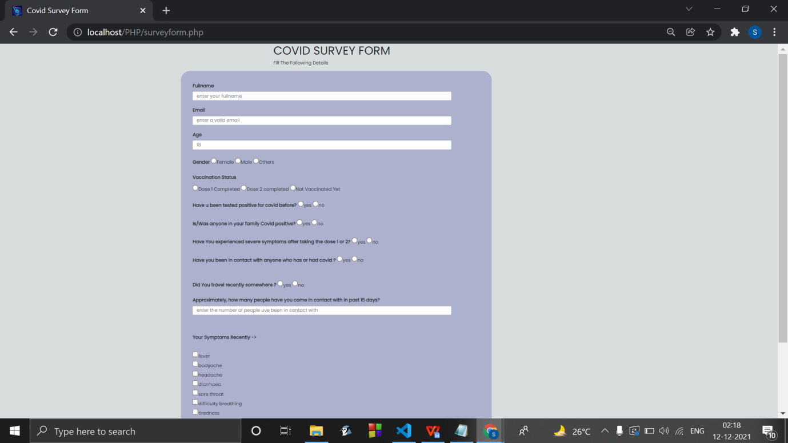

Covid variant information :

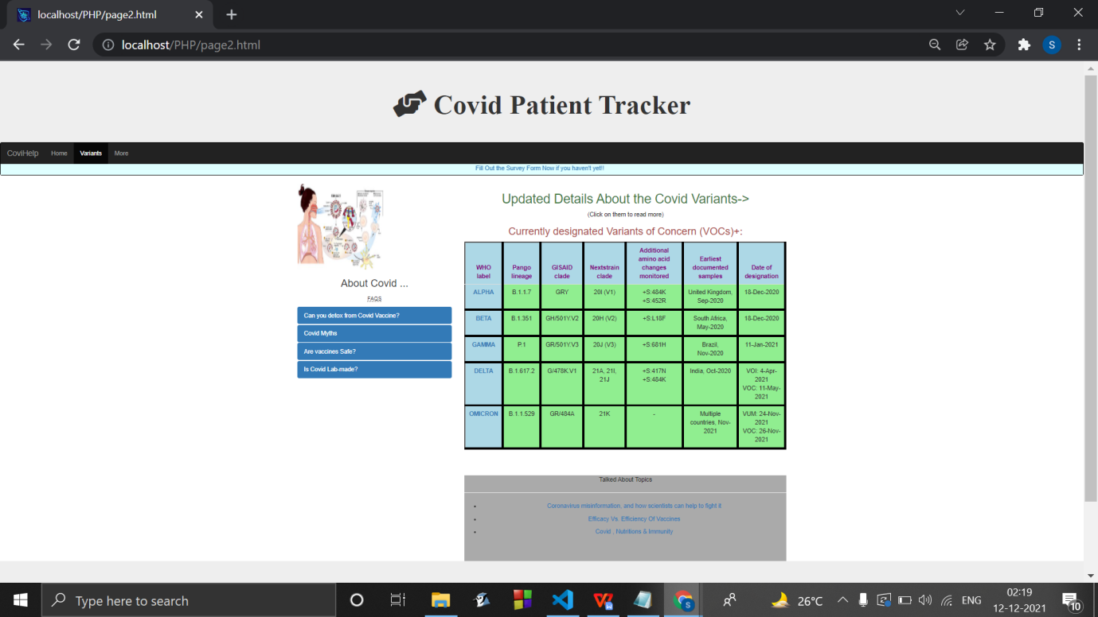

Viewing Covid Variant information on the left and having a search bar on the right :

(alongwith desktop notification)

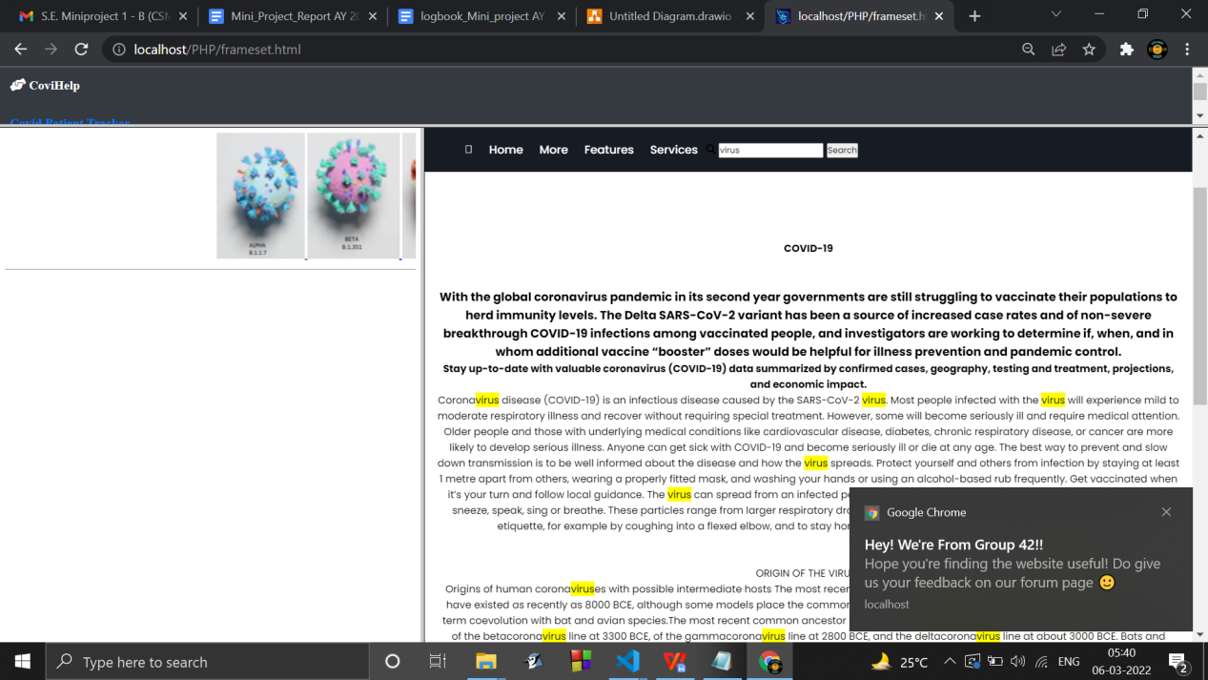

Covid data retrived from a dataset :

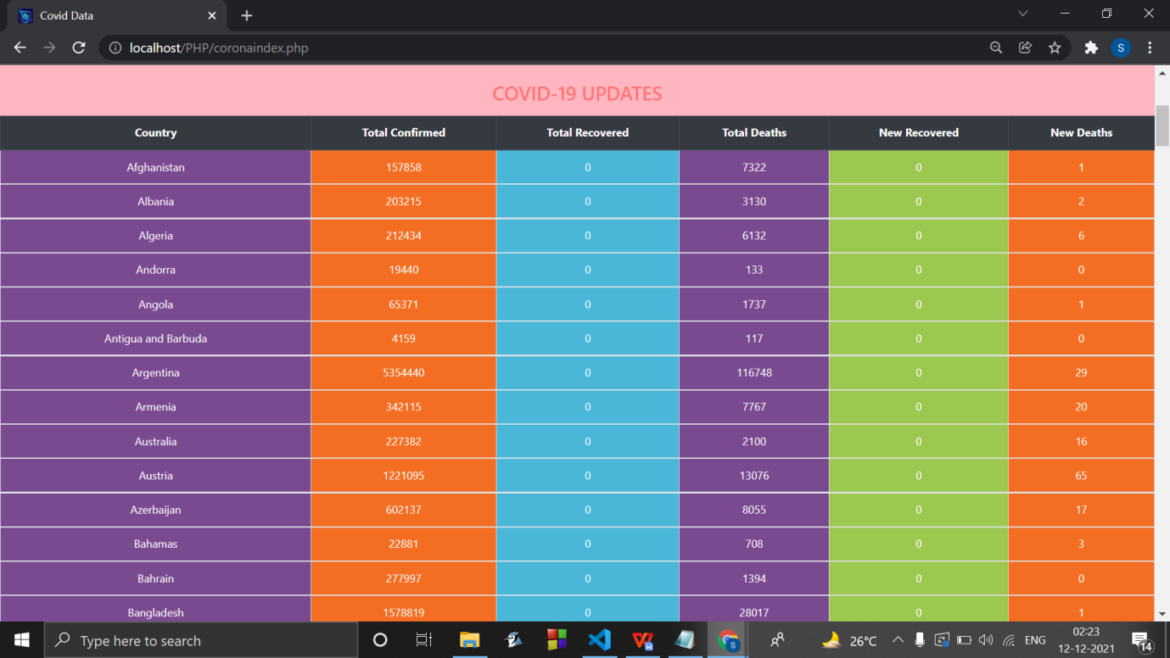

Database Connection :

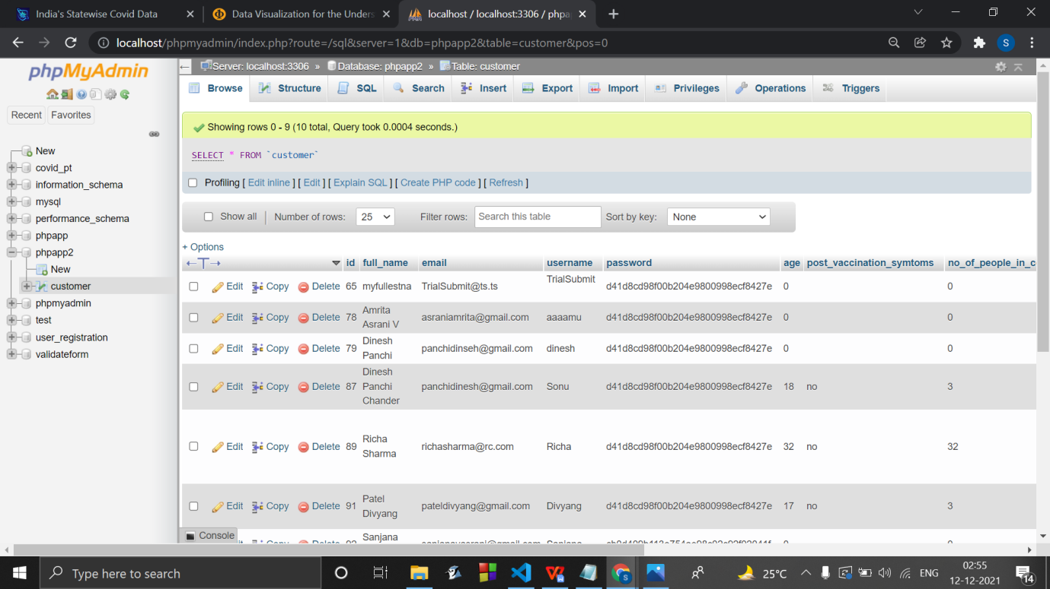

Forum home page :

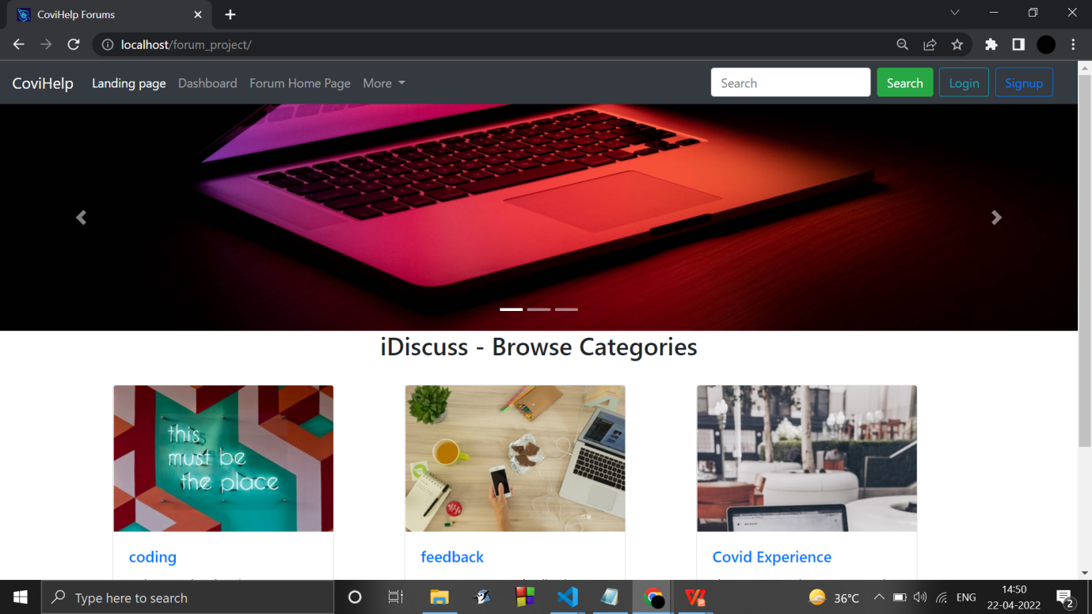

Signup modal :

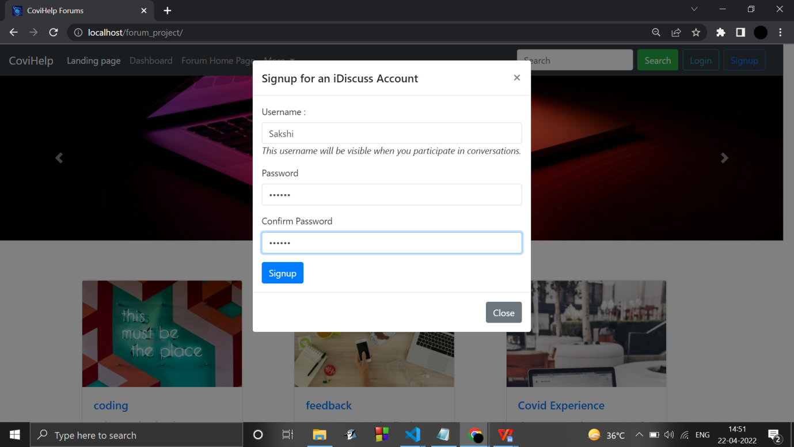

Login modal :

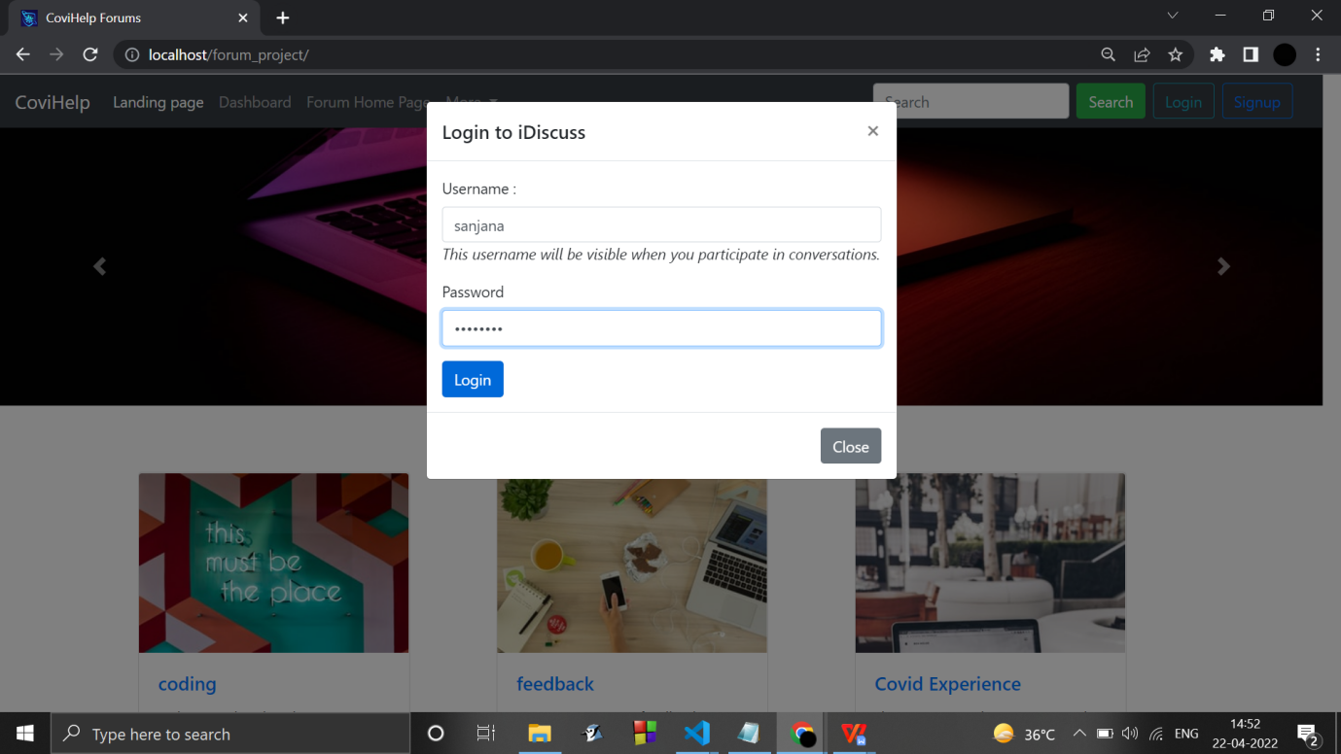

Posting a comment :

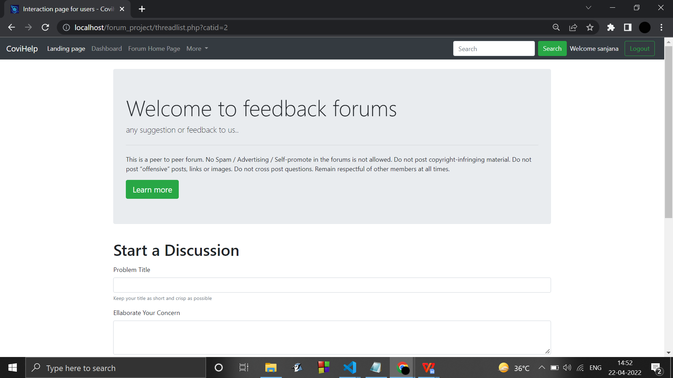

Posting a comment under a comment(thread) :

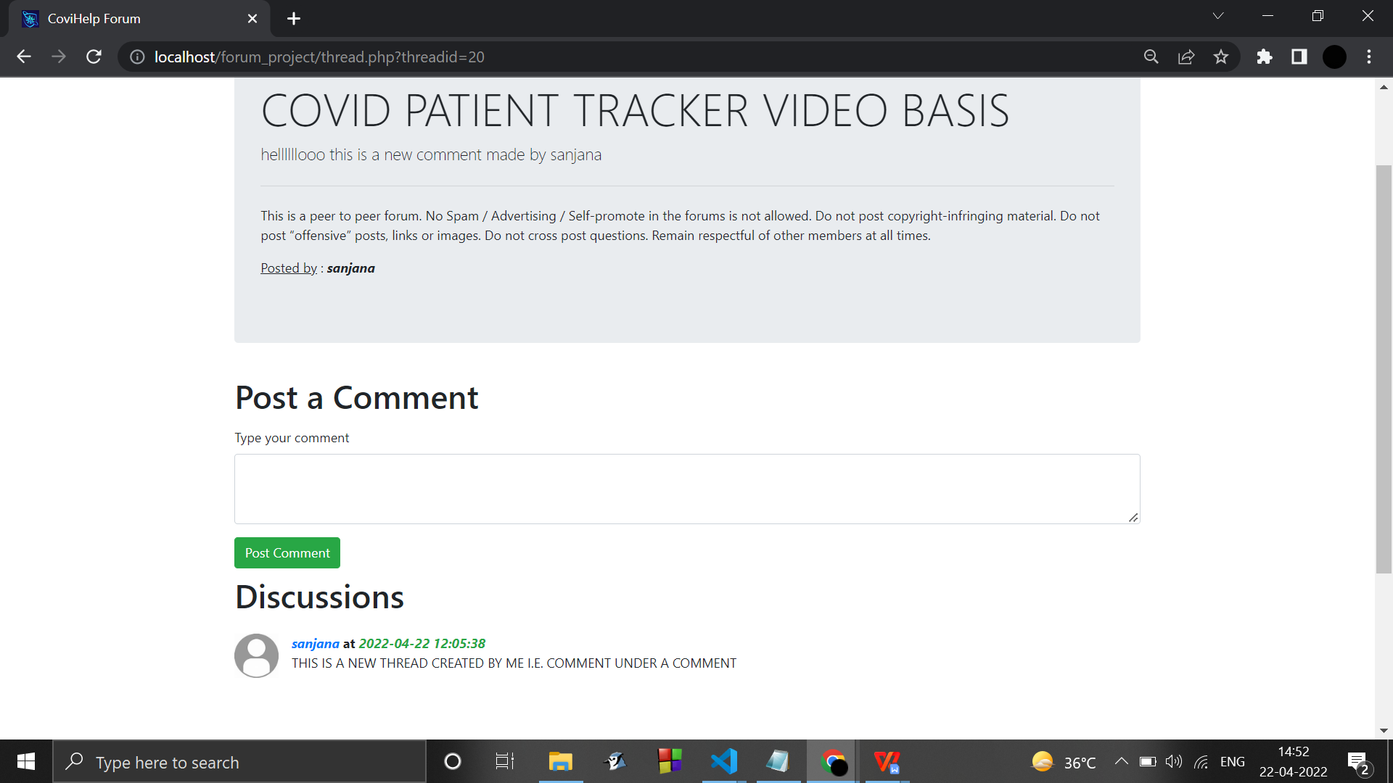

Searching keywords from the posts made :

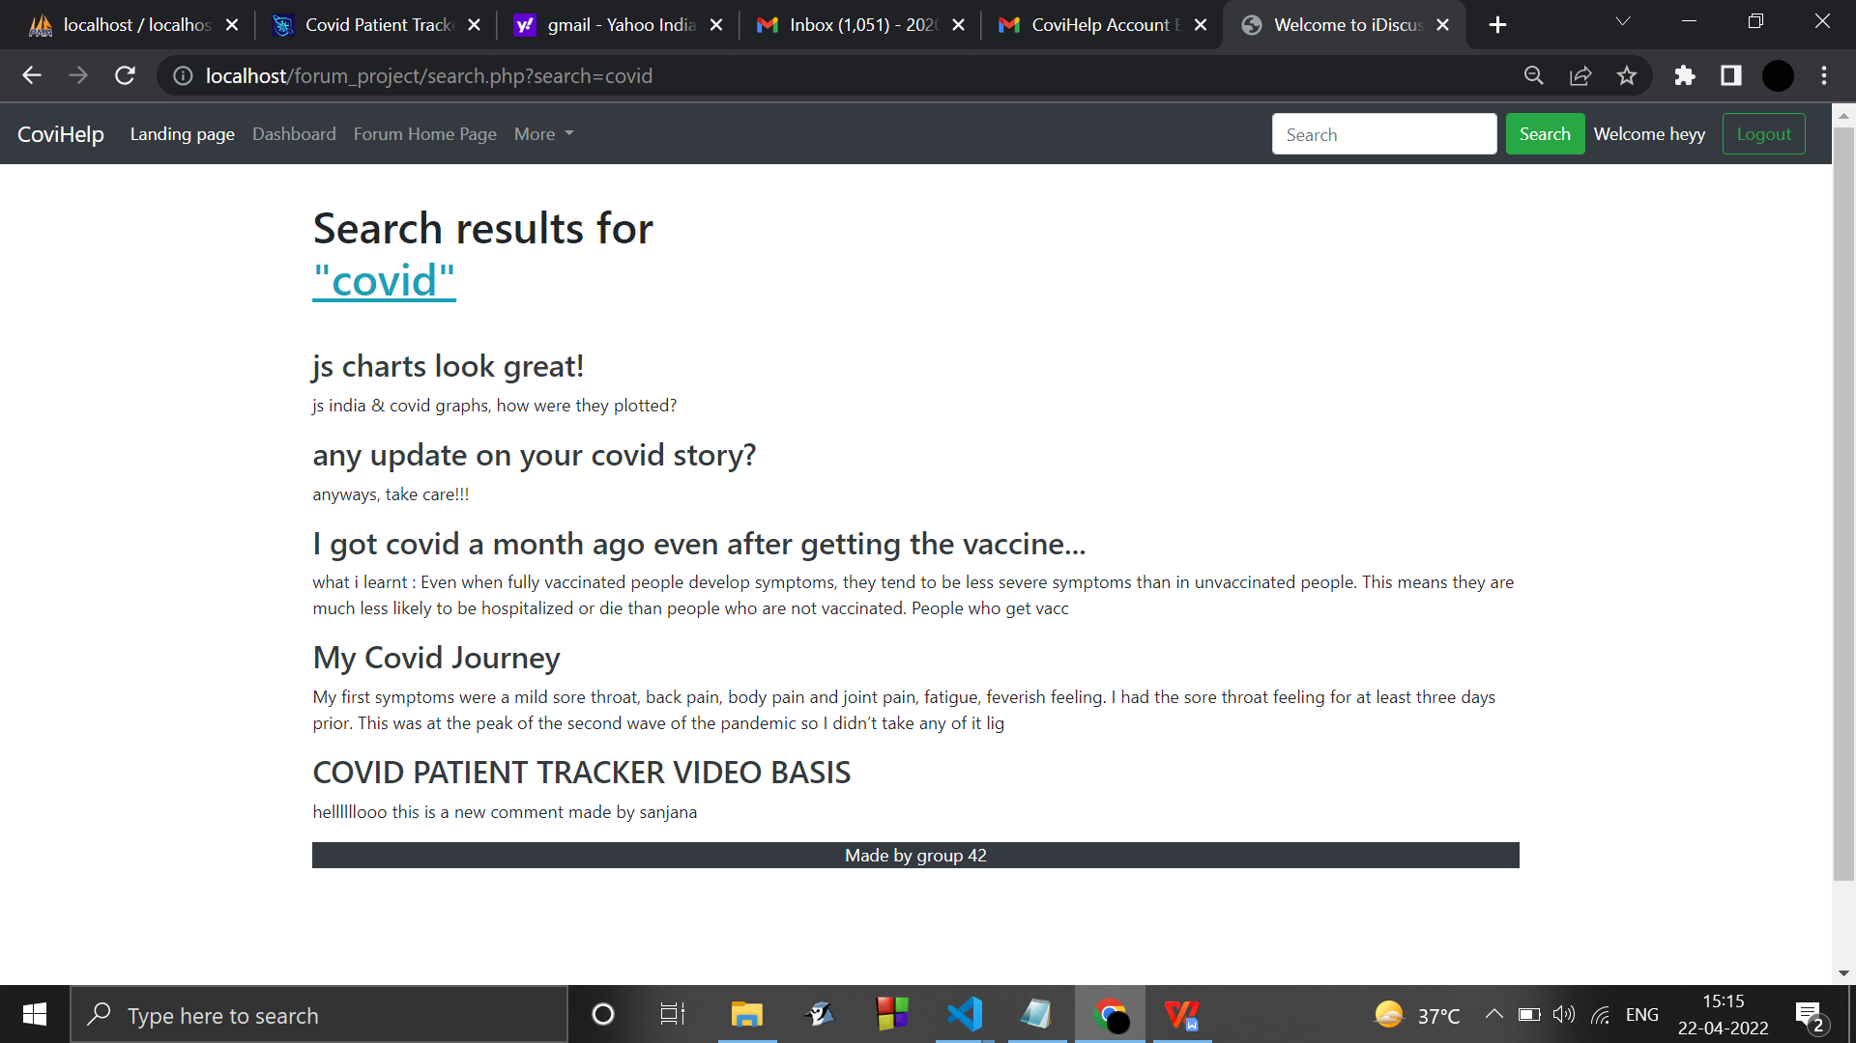

Admin functionalities :

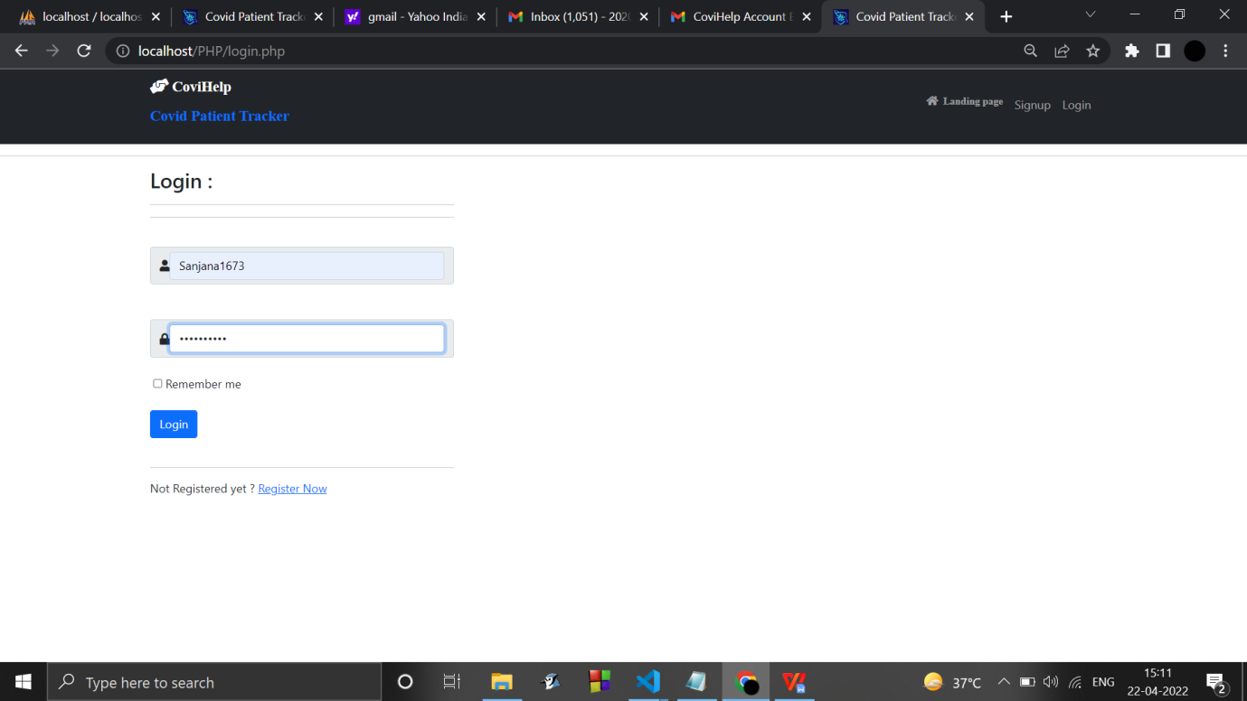

Admin dashboard :

(3 added functionalities )

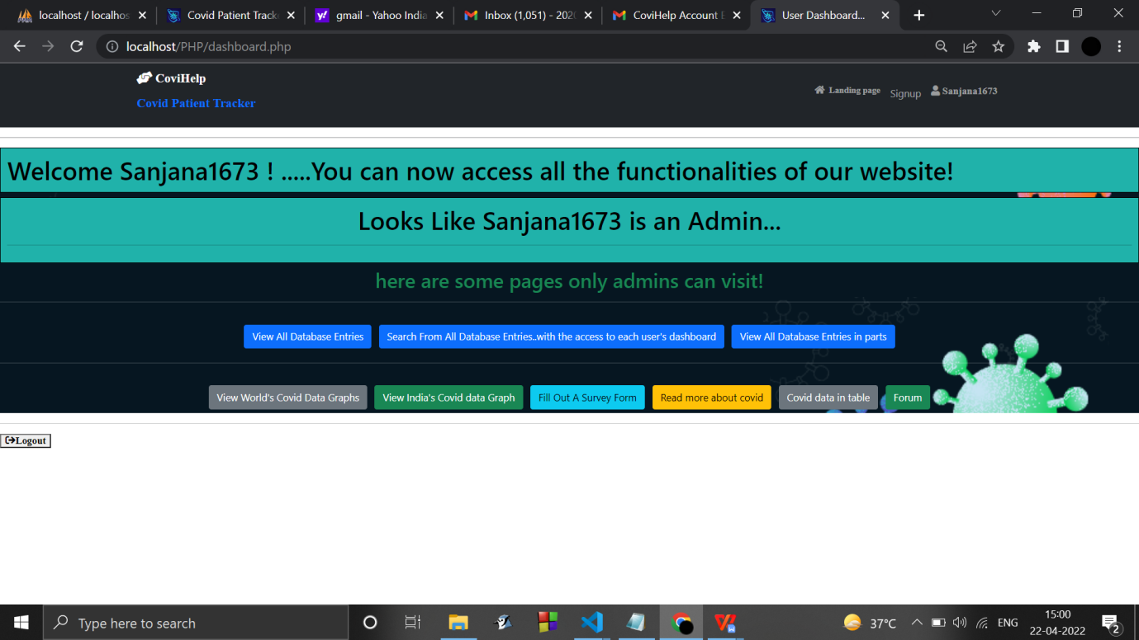

CRUD operations :

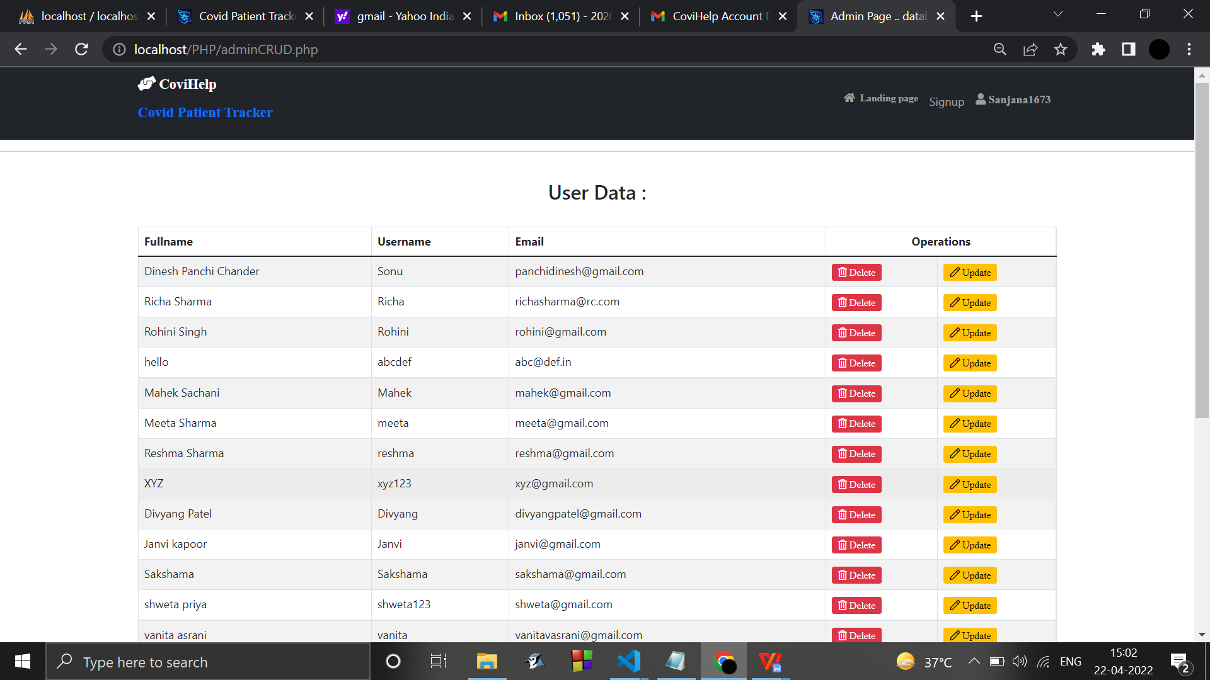

Pagination :

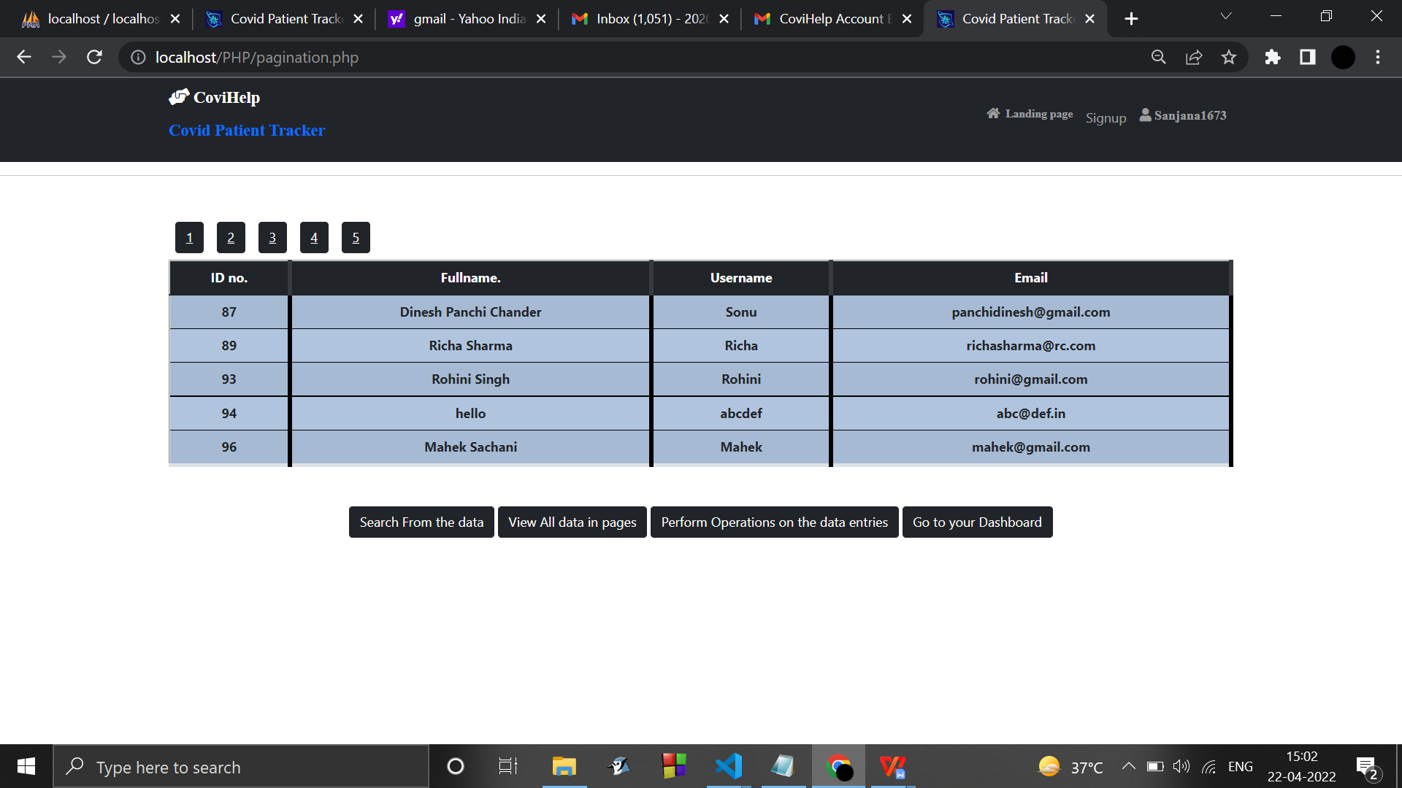

Searching from the database entries :

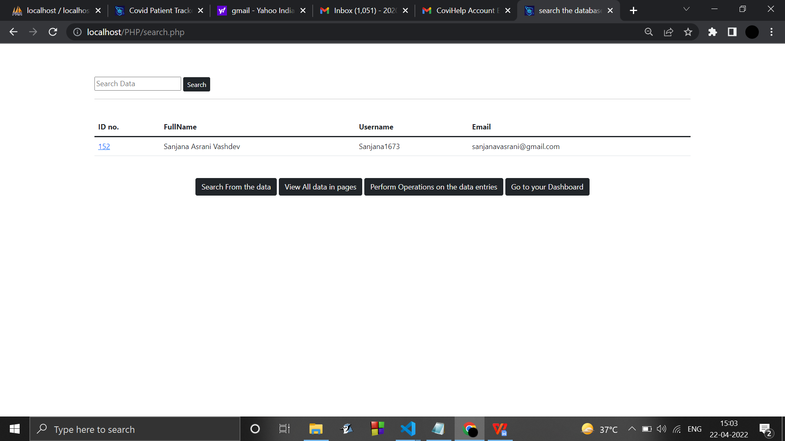

Accessing user’s account through admin :

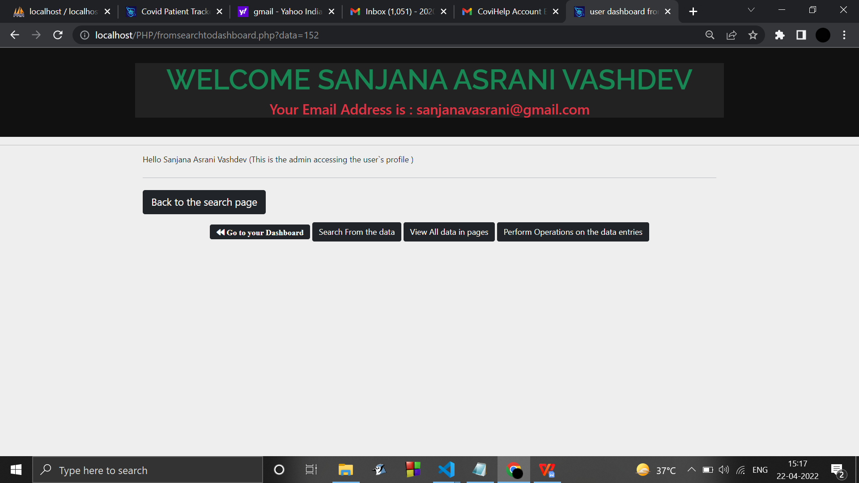

**3.6. Conclusion and Future work**

* Email linking & Generation of a secure link to process a secure login.
* A 'forgot password' option with the 'remember me ' option and 'show' password.
* Use cookies to make sure User gets logged out after a regular period of time .
* Enhance the UI/UX design.

**REFERENCES :**

* The Government of India. 2020. Live updates from Worldometer. Retrieved from <https://www.worldometers.info/coronavirus/country/india/>
* World Health Organization. 2020. Coronavirus disease 2019 (COVID-19): Situation report. Retrieved from <https://www.worldometers.info/coronavirus/?utm_campaign=homeAdvegas1?%20>.
* Alan L.Portal, Yi Zhang, Ying Huang, Mengjia Wu.Tracking and Mining the COVID-19 Research Literature. Retrieved from <https://doi.org/10.3389/frma.2020.594060>
* Fairoza Amira Binti Hamzaha, Cher Han Laub, Hafeez Nazric, Dominic Vincent Ligotd, Guanhua Leee, Cheng Liang Tanf, Mohammad Khursani Bin Mohd Shaibg,Ummi Hasanah Binti Zaidonh, Adina Binti Abdullahi, Ming Hong Chungj, Chin HweeOngk, Pei Ying Chewl and Roland Emmanuel Salungam. CoronaTracker: World-wide COVID-19 Outbreak Data Analysis and Prediction. Retrieved from <http://dx.doi.org/10.2471/BLT.20.255695>
* Haridimos Kondylakis, Dimitrios G Katehakis, Dimitrios Tzovaras and COVID-19 Mobile Apps: A Systematic Review of the Literature. Retrieved from <https://www.ncbi.nlm.nih.gov/pmc/articles/PMC7732358/>
* João L. D.Comba, Universidade Federal do Rio Grande do Su and Data Visualization for the Understanding of COVID-19. Retrieved from <https://www.computer.org/csdl/magazine/cs/2020/06/09222822/1nTpVintIu4>
* A. Kumar, P. K. Gupta and A. Srivastava and A review of modern technologies for tackling COVID-19 pandemic. Retrieved from <https://pubmed.ncbi.nlm.nih.gov/32413821/>
* M. U. Ashraf, A. Hannan, S. M. Cheema, Z. Ali and A. Alofi and Detection and Tracking Contagion using IoT-Edge Technologies: Confronting COVID-19 Pandemic. Retrieved from <https://ieeexplore.ieee.org/document/9179284>

**DATASETS RETRIEVED FROM :**

* <https://covid19.who.int/who-data/vaccination-data.csv>
* <https://covid19.who.int/WHO-COVID-19-global-table-data.cs>
* <https://www.kaggle.com/datasets>